**CSA1086 - Software Engineering**

GitHub Repository setup

1. Create a repo in git hub

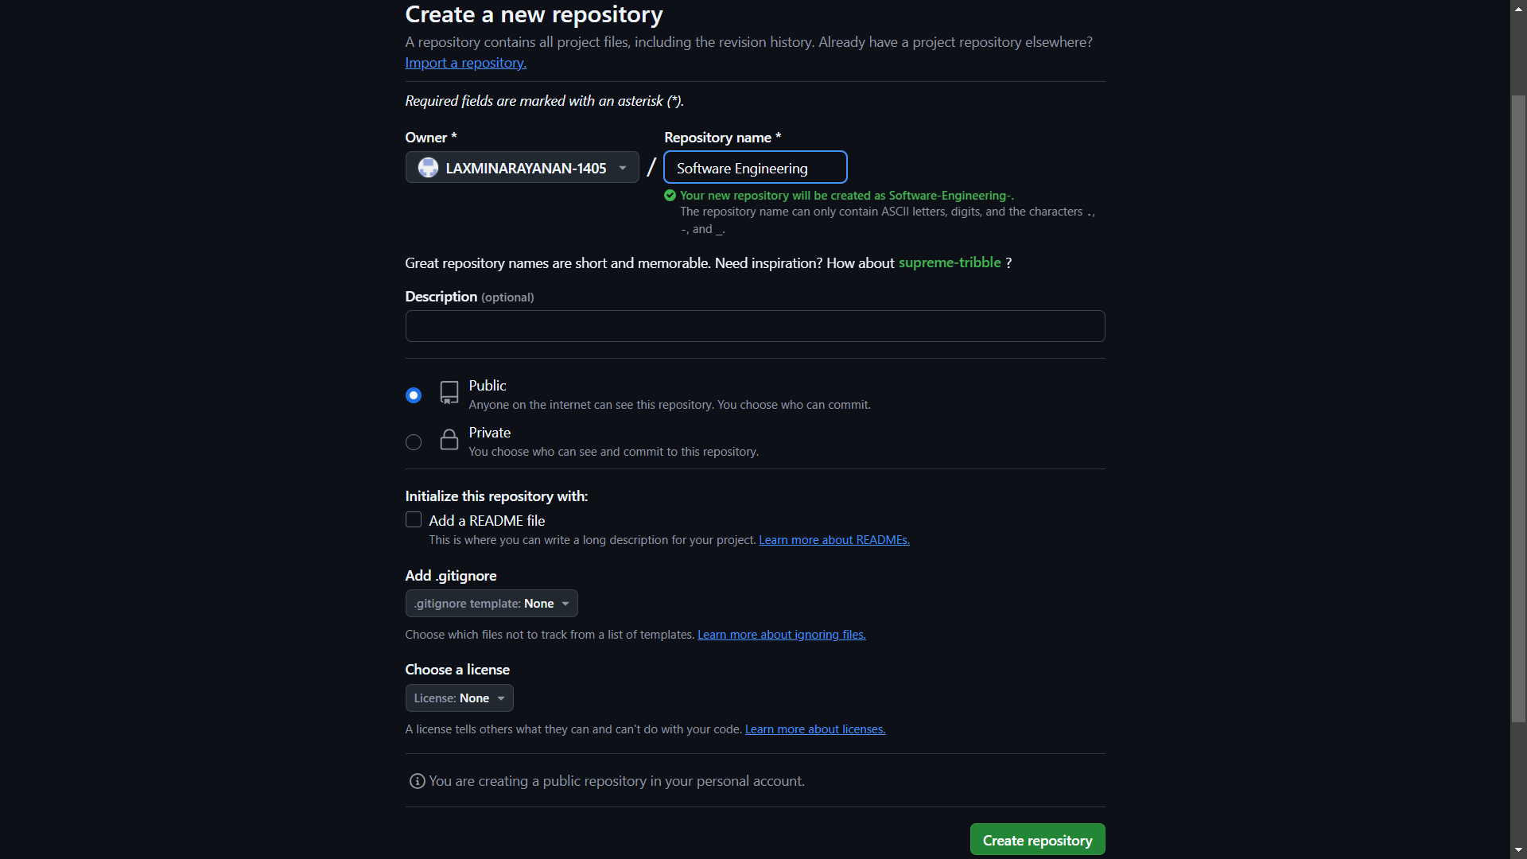

1. Commit the changes

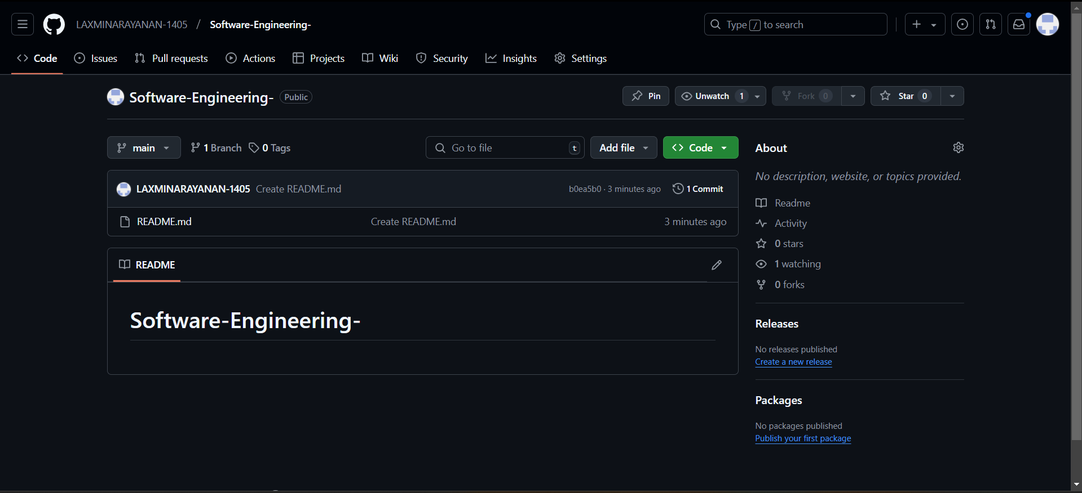

1. Clone your repo into the local computer

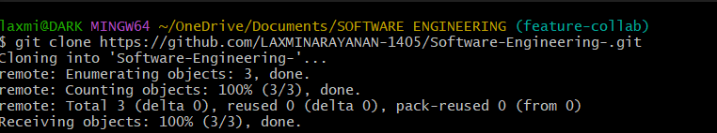

1. Open and edit your readme file



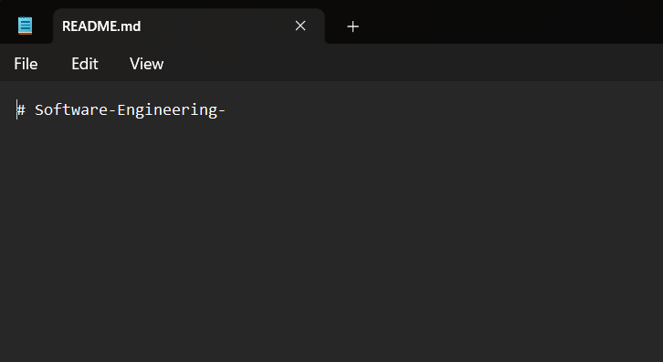

1. Commit and push the changes

